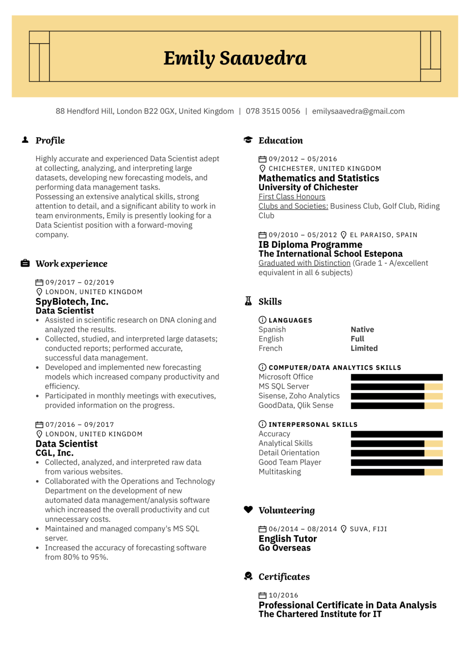
Emily Saavedra
88 Hendford Hill, London B22 OGX, United Kingdom | 078 3515 0056 | emilysaavedra@gmail.com
▲ Profile
Highly accurate and experienced Data Scientist adept at collecting, analyzing, and interpreting large datasets, developing new forecasting models, and performing data management tasks.
Possessing an extensive analytical skills, strong attention to detail, and a significant ability to work in team environments, Emily is presently looking for a Data Scientist position with a forward-moving company.
Work experience
09/2017 - 02/2019
LONDON, UNITED KINGDOM
SpyBiotech, Inc.
Data Scientist
• Assisted in scientific research on DNA cloning and
Education
09/2012 05/2016
CHICHESTER, UNITED KINGDOM Mathematics and Statistics University of Chichester First Class Honours
Clubs and Societies: Business Club, Golf Club, Riding Club
09/2010
05/2012 EL PARAISO, SPAIN
IB Diploma Programme
The International School Estepona
Graduated with Distinction (Grade 1 - A/excellent equivalent in all 6 subjects)
A Skills
analyzed the results.
•
Collected, studied, and interpreted large datasets; conducted reports; performed accurate,
LANGUAGES
Spanish
English
French
Native Full Limited
·
successful data management.
Developed and implemented new forecasting
models which increased company productivity and efficiency.
• Participated in monthly meetings with executives,
provided information on the progress.
07/2016 - 09/2017
LONDON, UNITED KINGDOM
Data Scientist
CGL, Inc.
Collected, analyzed, and interpreted raw data
from various websites.
• Collaborated with the Operations and Technology Department on the development of new
•
automated data management/analysis software which increased the overall productivity and cut unnecessary costs.
Maintained and managed company's MS SQL
server.
• Increased the accuracy of forecasting software from 80% to 95%.
→ COMPUTER/DATA ANALYTICS SKILLS Microsoft Office
MS SQL Server
Sisense, Zoho Analytics
GoodData, Qlik Sense
INTERPERSONAL SKILLS
Accuracy
Analytical Skills
Detail Orientation Good Team Player Multitasking
Volunteering
06/2014 08/2014 SUVA, FIJI
English Tutor
Go Overseas
Certificates
10/2016
Professional Certificate in Data Analysis The Chartered Institute for IT

